
SCHOOL OF COMPUTING AND ENGINEERING SCIENCES (SCES)
BACHELOR OF SCIENCE IN ELECTRICAL AND ELECTRONICS
ENGINEERING (BSEEE)
PLC AND INDUSTRIAL AUTOMATION
TECHNICAL PROJECT PROPOSAL:

SMART STREET SECURITY & LIGHTING SYSTEM

BY
Edward Mwongela
142092

Lecturer: Omae Malack Oteri
2nd Feb 2025

Contents
List of figures 2
Abstract 3
Introduction 4
Background Information 4
Problem Statement 4
Relevance of the Study/Justification 4
Objectives 4
Scope of the Project 5
Concept of Operations (ConOps) 5
Literature Review 7
Apparatus/Components: 7
Research Gap 9
Methodology/Procedure 10
Simulation code 12
Expected results 15
Timeframe 15
Budget 16
Conclusion and recommendations 16
References 17

List of figures
Figure 1. TinkerCAD model simulation 11
Figure 2. open PLC implementation 11

Abstract
The Smart Street Security & Lighting System aims to enhance public safety and energy efficiency by integrating motion detection and light sensors to optimize street lighting and surveillance. Using an Arduino-based control system, the project automates lighting and security alerts, reducing energy consumption and improving safety in public spaces. Expected outcomes include reduced light pollution, enhanced security, and energy savings.

Introduction

Background Information
Public lighting plays a crucial role in urban and rural safety. While traditional street lighting systems have been effective in providing illumination, they lack the intelligence to adapt to real-time conditions, leading to inefficiencies in energy use and security monitoring.
Additionally, security threats such as vandalism and unauthorized access to public areas remain a concern. A smart lighting and security system can mitigate these issues by using sensors to detect movement and low-light conditions, ensuring efficient energy use and real-time security monitoring.

Problem Statement
The project is necessary to improve energy efficiency, enhance security, and provide a cost-effective solution for smart urban infrastructure. By integrating automation into public lighting and security systems, the project aims to reduce energy wastage, lower operational costs, and improve safety in public spaces. Municipalities and utility companies stand to benefit from reduced energy bills and maintenance costs.

Relevance of the Study/Justification
The project is necessary to improve energy efficiency, enhance security, and provide a cost-effective solution for smart urban infrastructure. By integrating automation into public lighting and security systems, the project aims to reduce energy wastage, lower operational costs, and improve safety in public spaces.[1]

Objectives
- To design and develop a smart street security and lighting system that integrates motion detection and low-light sensing, achieving a 30% reduction in energy consumption compared to traditional systems.
- To analyze and implement an energy-efficient lighting control mechanism based on real-time environmental data.
- To develop and test a security response system that activates alarms and surveillance cameras upon detecting unauthorized movement, with a response time of less than 5 seconds
- To integrate and optimize a Bluetooth communication module for remote monitoring and control of the system.
- To implement and evaluate the effectiveness of the system in reducing energy consumption and enhancing security.

Scope of the Project
The system will focus on street lighting automation and security enhancement for public spaces such as residential areas, parking lots, and roadways. It will include real-time monitoring capabilities and will be scalable for large-scale implementation. However, challenges such as varying environmental conditions and the need for robust hardware in outdoor settings will be considered during development.

Concept of Operations (ConOps)
The Smart Street Security & Lighting System operates by detecting movement and low-light conditions, triggering the necessary lighting and surveillance components. The system aims to:
- Improve security by activating cameras and lights when motion is detected.
- Reduce energy consumption by turning off streetlights when no activity is present.
- Provide real-time system status updates via an LCD display.
- Allow remote access and monitoring through a Bluetooth module.

Possible Key Stakeholders
- Municipal Authorities: Oversee deployment and maintenance.[2]
- Law Enforcement: Utilize surveillance footage for security purposes.
- Residents & Pedestrians: Benefit from improved security and lighting.
- Utility Companies: Monitor energy consumption and optimize power usage.

Operational Scenarios
Scenario 1: Normal Operation
- During daylight hours, streetlights remain off while the system remains in standby mode.
- Cameras operate in low-power mode unless motion is detected.
- The LCD display shows system status.
Scenario 2: Motion Detected at Night
- The motion sensor detects movement and triggers the streetlights to turn on.
- The security camera records the activity.
- The system logs the event and sends data to a remote monitoring unit if connected via Bluetooth.
Scenario 3: Low-Light Conditions Without Motion
- When ambient light drops below a set threshold, the system gradually turns on the streetlights.
- If no motion is detected, the system operates at minimal brightness to conserve energy.
Scenario 4: Manual Override & Remote Monitoring
- Authorized personnel can override the system using a Bluetooth-enabled device.
- The LCD provides status updates and system health reports.

Literature Review
Several studies have explored smart lighting and security systems using IoT and automation. For example, [3] discusses the use of IoT for energy-efficient street lighting, while [4] focuses on security monitoring using motion sensors. However, most solutions lack an integrated approach that combines both functionalities. This project addresses this gap by merging lighting automation with real-time security surveillance, offering a comprehensive solution for urban safety.

Apparatus/Components:
- Arduino Uno (Microcontroller) - Manufacturer: Arduino, Model: Uno R3
This device has an ATMega328 microcontroller, six analog inputs, and 13 digital input/outputs.[5]
  - Operating Voltage: 5V
- Input Voltage: 7-12V
- Digital I/O Pins: 14
- Analog Input Pins: 6
- Clock Speed: 16 MHz
- Flash Memory: 32 KB (0.5 KB used by bootloader)
- SRAM: 2 KB
- EEPROM: 1 KB
- PIR Motion Sensor - Detects movement:
Passive Infrared (PIR) sensors detect heat energy by comparing the signals from a pair of pyroelectric elements. The supporting circuitry then sends a HIGH signal to its signal wire.[6]
  - Detection Range: Up to 7 meters
  - Operating Voltage: 5V-12V
  - Output: Digital HIGH/LOW signal
  - Adjustable sensitivity and delay time
- Photoresistor - Monitors ambient light levels:
When light energy contacts the sensor, the material absorbs some of the light energy and converts it to electrical energy, becoming less resistive.[7]
  - Resistance Range: 200 Ω (bright light) to 20 MΩ (dark)
- Operating Voltage: 3.3V-5V
- Response Time: 20-30 ms
- Relay Module - Controls streetlights and security components
  - Operating Voltage: 5V
- Max Load: 10A 250V AC or 10A 30V DC
- Optically isolated for safety
- Bluetooth Module (HC-05/HC-06) - Wireless communication[8]
  - Operating Voltage: 3.3V-5V
- Range: Up to 10 meters
- Baud Rate: 9600 (default)
- Compatible with Arduino and smartphones
- LED RGB – simulate streetlight and emergency warning lights:
LEDs are made from semiconductor materials that emit light when current flows through them in the correct direction. RGB LEDs have three separate LEDs inside: red, green, and blue, which share a common cathode pin. The light from these can be mixed to create any color of visible light. Too much current can damage or break LEDs, so add resistors in series to limit the current flow.
  - Operating Voltage: 3.3V-5V
- Current: 20 mA per color (Red, Green, Blue)
- Common Cathode configuration
- LCD Display (16x2) - Displays system status:
LCDs contain many layers of materials. There’s an LED backlight, as well as a sandwich of polarized glass around liquid crystals, which can electronically rotate the polarized light to allow the backlight to pass through and be seen, or be blocked by the polarizer on top.[9]
  - Operating Voltage: 5V
- Interface: I2C or parallel
- Backlight: LED
- Dimensions: 80mm x 36mm x 12mm
- Buzzer (piezo) - Alerts in case of security threats:
Piezos can convert alternating electrical current into sound (vibration), and vice versa.
  - Operating Voltage: 3.3V-5V
- Sound Output: 85 dB at 10 cm
- Frequency Range: 2-4 kHz
- Security Camera (Modelled Actuator – DC motor) - Simulated activation upon movement detection
- Vibration sensor (Modelled sensor – push button) - detects tampering with the system[10]
  - Operating Voltage: 5V
- Output: Digital HIGH/LOW signal
- Durability: 1 million presses
- Resistors:
A resistor uses up some of a circuit's current and converts it into heat. It does this by giving the electricity a longer, thinner, and slightly less conductive path to travel. Resistors are used in all kinds of circuits, from helping LEDs keep from burning out, to adjusting the frequency of radio signals.

Research Gap
Existing studies primarily focus on either lighting automation or security monitoring. This project bridges the gap by integrating both functionalities into a single system, offering a comprehensive solution for urban safety.[11]

Methodology/Procedure
- System Design: Develop the circuit layout and select appropriate sensors and actuators.
- Programming & Development: Write the control logic using Arduino IDE and Open PLC software.
- Hardware Integration: Connect sensors, actuators, and communication modules:
- Photoresistor - A resistor has two wire leads and should be connected in series with the device it's meant to control. Photoresistors are not polarized, which means you can connect them either way around.
- Arduino Uno (Microcontroller) - Connect 5V and GND pins to your breadboard power and ground rails, respectively. Connect other external components depending on your code.
- DC motor - This device has two wire leads. Connect Positive to power and Negative to ground to make the motor spin.
- LCD - This device has 4 wire leads. Connect VCC to 5V on an Arduino and GND to any GND terminal on an Arduino. The other pins control the display contrast, data communication with the microcontroller, and LED backlight.
- LED RGB - This device has four wire leads. The Cathode pin is wired to lower voltage, and each of the three color pins is wired to higher voltage to power each color LED. Be sure to limit the current flow with resistors
- PIR sensor - There are three pins at the bottom of the device. Power the device by connecting the Power pin to the 5V and Ground to ground. The Signal pin is connected to a device directly, or any digital or analog terminal on an Arduino.
- A resistor – it has two wire leads, and should be connected in series with the device it's meant to support. Resistors are not polarized, which means you can connect them either way around and they will work the same.
- Piezo - This device has two wire leads. It can be connected either way around to produce sound. One terminal is connected to a PWM signal such as from an Arduino, and the other is connected to ground.
- Bluetooth module - connect the PWR pin to the 5V pin on Wiring, connect the GND pin to the GROUND pin on wiring. Then connect the Rx pin to the Tx pin of Wiring (digital pin 3) and connect the Tx pin to the Rx pin of Wiring (digital pin 2)
- Testing & Calibration: Optimize sensor sensitivity, lighting thresholds, and security response. Conduct multiple test runs in varying light and motion conditions to ensure reliability. Calibrate the system to minimize false positives and ensure accurate detection of motion and light levels.
- Deployment & Evaluation: Test in a simulated environment and refine based on real-world data.
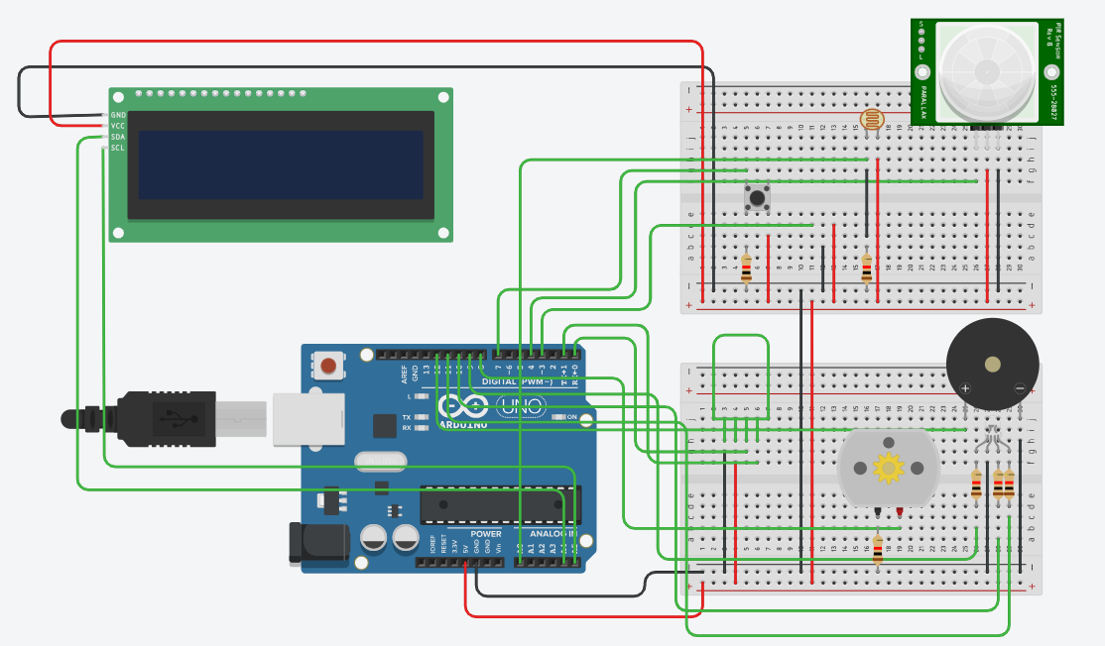
Figure 1. TinkerCAD model simulation
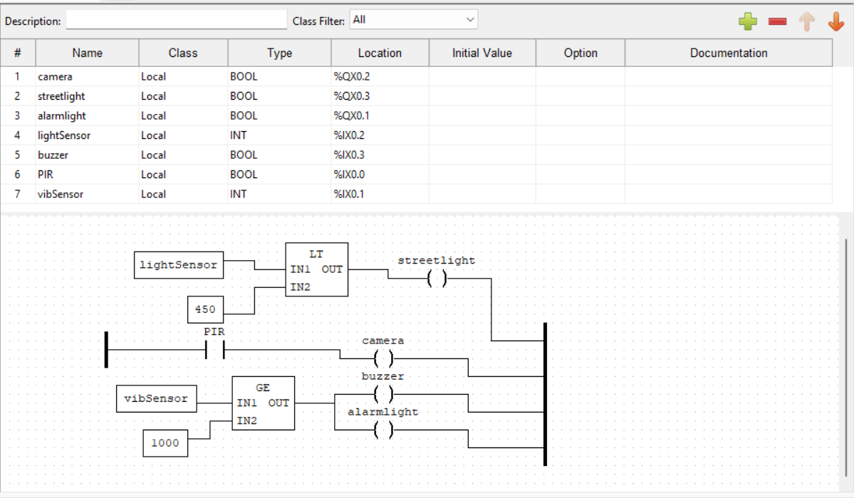
Figure 2. open PLC implementation

Simulation code
// C++ code
/*DESIGN & IMPLEMENT AN INSTRUMENTATION SYSTEM TO
ADDRESS ANY CHALLENGE IN ANY FIELD OF APPLICATION. THE
SYSTEM SHOULD INCLUDE AN LCD, A BLUETOOTH MODULE, THREE
SENSORS & THREE ACTUATORS WITH ONE OF THE SENSORS &
ACTUATORS BEING MODELLED. TO BE PRESENTED DURING THE LAST
WEEK OF THE SEMESTER.*/

#include <LiquidCrystal_I2C.h>
int light = 0;
int obstacleDetect = 0;
int buzzer = 0;
LiquidCrystal_I2C lcd(32,16,2);

void setup()
{
lcd.init();
lcd.backlight();
lcd.display();
pinMode(2, INPUT);
pinMode(3, INPUT);
pinMode(4, INPUT);
pinMode(7, INPUT);
pinMode(8, OUTPUT);
pinMode(9, OUTPUT);
pinMode(10, OUTPUT);
pinMode(11, OUTPUT);
pinMode(13, OUTPUT);
Serial.begin(9600);
lcd.setCursor(4,0);
lcd.print("SYSTEM");
lcd.setCursor(4,1);
lcd.print("ACTIVE");
delay(2000);
}

void loop()
{
int A = digitalRead(9);//camera
Serial.print("A = ");
Serial.println(A);
int B = digitalRead(7);//vibration sensor
Serial.print("B = ");
Serial.println(B);
int C = digitalRead(4);//PIR sensor
Serial.print("C = ");
Serial.println(C);
int D = analogRead(A0);//ambient sensor
Serial.print("D = ");
Serial.println(D);
if (Serial.available()>0){
String data = Serial.readString();
Serial.print("data");
Serial.println(data);
if (data =="on"){
digitalWrite(13,HIGH);
digitalWrite(10,HIGH);
digitalWrite(9,HIGH);
delay(2000);
}
else if(data=="off"){
digitalWrite(13,LOW);
digitalWrite(10,LOW);
digitalWrite(9,LOW);
lcd.clear();
lcd.setCursor(0,0);
lcd.print("SYSTEM OFFLINE");
delay(2000); }
}
if(C== HIGH){
digitalWrite(8, HIGH);
analogWrite(9, 0);//green
analogWrite(10, 0);
analogWrite(11, 153);
delay(10000);
digitalWrite(8, LOW);
analogWrite(9, 0);
analogWrite(10, 0);
analogWrite(11, 0);
}
if (B == HIGH){
Serial.println("OBSTRUCTION IMMINENT");
lcd.clear();
lcd.setCursor(2,0);
lcd.print("OBSTRUCTION");
lcd.setCursor(2,1);
lcd.print("IMMINENT");
analogWrite(9, 255);//red
analogWrite(10, 0);
analogWrite(11, 0);
digitalWrite(12, HIGH);
delay(70);
}
else{
Serial.println("NO OBSTRUCTION");
lcd.clear();
lcd.setCursor(6,0);
lcd.print("NO");
lcd.setCursor(2,1);
lcd.print("OBSTRUCTION");
digitalWrite(12, LOW);
delay(70);
}
if(D > 450) {
Serial.println("daylight mode active");
lcd.clear();
lcd.setCursor(0,0);
lcd.print("DAY MODE");
lcd.setCursor(2,1);
lcd.print("active");
analogWrite(9, 255);//red
analogWrite(10, 0);
analogWrite(11, 0);
delay(70);
}
else if(D > 225&& D <450 ){
Serial.println("night mode loading");
lcd.clear();
lcd.setCursor(3,0);
lcd.print("NIGHT MODE");
lcd.setCursor(4,1);
lcd.print("loading");
delay(70);
}
else{
Serial.println("night mode active");
lcd.clear();
lcd.setCursor(3,0);
lcd.print("NIGHT MODE");
lcd.setCursor(4,1);
lcd.print("active");
analogWrite(9, 0);//blue
analogWrite(10, 204);
analogWrite(11, 204);
delay(70);
}
}

Expected results
- Automated street lighting system that activates only when necessary, reducing energy consumption by up to 30%.
- Improved public safety with real-time intrusion detection and a response time of less than 5 seconds.
- Enhanced monitoring and control via Bluetooth communication, allowing for remote system management.

Timeframe
Task | Duration | Milestones
System Design | 2 Weeks | Finalize system architecture  Create circuit diagrams and flowcharts
Component Selection & Procurement | 1 Week | Purchase all required components  Verify component compatibility
Software Development | 3 Weeks | Write and test Arduino code  Integrate Bluetooth communication
Hardware Integration | 2 Weeks | Assemble and connect all components  Test individual modules
Testing & Optimization | 3 Weeks | Calibrate sensors  Optimize system performance  Fix bugs
Final Deployment & Evaluation | 2 Weeks | Deploy in a simulated environment  Collect data and evaluate results

Budget
Component | Estimated Cost (KES)
Arduino Uno | 2,500
PIR Sensor | 1,200
LDR Sensor | 500
Relay Module | 800
Bluetooth Module | 1,500
LCD Display | 2,000
Buzzer/Alarm | 1,000
Miscellaneous (Wires, PCB, etc.) | 2,500
Contingency fund | 1500
Total | 13,500

Conclusion and recommendations
This project provides an innovative solution to enhance street security and optimize energy consumption through an automated lighting system. Future improvements could include solar power integration, GSM-based alerts, or AI-driven surveillance for advanced threat detection. Further testing in real-world environments will be required to ensure scalability and effectiveness. We recommend that municipalities and utility companies consider piloting this system in select areas to evaluate its performance and potential for broader implementation

References
[1] “Smart Home Systems Kenya | Home Automation Solutions.” Accessed: Mar. 16, 2025. [Online]. Available: https://www.talinda.net/smart-homes
[2] “Nairobi Smart Street Lighting Project – PPP Directorate.” Accessed: Mar. 16, 2025. [Online]. Available: https://pppkenya.go.ke/ova_por/nairobi-smart-street-lighting-project/
[3] S. Gouram, S. K. Hasane, J. Somlal, S. D. Pande, P. Ganjewar, and K. Pawar, “Development of IOT Based Smart Street Lighting System,” in 2024 International Conference on Innovation and Novelty in Engineering and Technology (INNOVA), Dec. 2024, pp. 1–5. doi: 10.1109/INNOVA63080.2024.10847046.
[4] I. V. Paputungan, M. R. Al Fitri, and U. Y. Oktiawati, “Motion and Movement Detection for DIY Home Security System,” in 2019 IEEE Conference on Sustainable Utilization and Development in Engineering and Technologies (CSUDET), Nov. 2019, pp. 122–125. doi: 10.1109/CSUDET47057.2019.9214684.
[5] “UNO R3 | Arduino Documentation.” Accessed: Mar. 21, 2025. [Online]. Available: https://docs.arduino.cc/hardware/uno-rev3/
[6] “Circuit design project,” Tinkercad. Accessed: Mar. 16, 2025. [Online]. Available: https://www.tinkercad.com/things/4OzQhFyGNga?googleCourseId=""&googleItemId=""&googleAttachmentId=""
[7] W. Storr, “Light Sensor including Photocell and LDR Sensor,” Basic Electronics Tutorials. Accessed: Mar. 21, 2025. [Online]. Available: https://www.electronics-tutorials.ws/io/io_4.html
[8] “Serial Port Bluetooth Module (Master/Slave) : HC-05 - ITEAD Wiki.” Accessed: Mar. 21, 2025. [Online]. Available: https://wiki.iteadstudio.com/Serial_Port_Bluetooth_Module_(Master/Slave)_:_HC-05
[9] S. Campbell, “Arduino LCD Set Up and Programming Guide,” Circuit Basics. Accessed: Mar. 21, 2025. [Online]. Available: https://www.circuitbasics.com/how-to-set-up-an-lcd-display-on-an-arduino/
[10] “How to Wire and Program a Button | Arduino Documentation.” Accessed: Mar. 21, 2025. [Online]. Available: https://docs.arduino.cc/built-in-examples/digital/Button/
[11] “IEEE Xplore Search Results.” Accessed: Mar. 16, 2025. [Online]. Available: https://ieeexplore.ieee.org/search/searchresult.jsp?newsearch=true&queryText=smart%20street%20lighting%20and%20security

